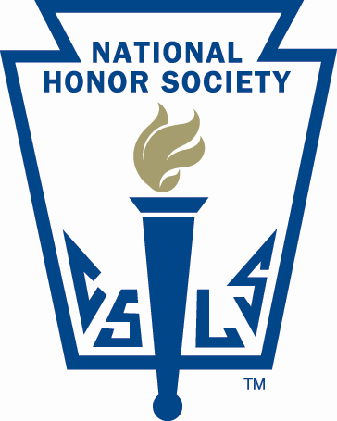
Lisbon Regional School
National Honor Society

25 Highland Avenue
Lisbon, New Hampshire 03585

FACULTY SPONSOR FORM

STUDENT’S NAME: _________________________________________

FACULTY SPONSOR: ________________________________________

Lisbon Regional School National Honor Society is asking that all new candidates for membership in our chapter of National Honor Society find a faculty sponsor who will guide the student through selection process and participate in the induction ceremony. The Faculty Council respectively requests that the Faculty Sponsor provide the candidate with a letter of reference that attributes to the student’s ability to fulfill their responsibilities to National Honor Society.

Thank You,

Tracy Locke
Advisor

Each candidate should return this form with your Faculty Sponsor’s name and Letter of Reference with the Information Packet.

