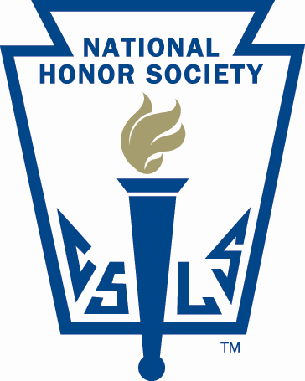
Lisbon Regional School
National Honor Society

25 Highland Avenue
Lisbon, New Hampshire 03585

Student Contract

I, _______________________, do hereby agree to the following terms and I understand that failing to follow them will result in my dismissal from membership in National Honor Society.

I agree to:
- At all times, act in accordance with all rules set forth in the Lisbon Regional School Student Handbook.
- Uphold the ordinances, obligations, and rules set forth by the National Honor Society.
- Not be present personally when character and leadership forms are completed.
- Not personally return character and leadership forms.

The most important term to remember is that National Honor Society maintains a zero policy for cheating and plagiarism. If you cheat or plagiarize, you will be immediately removed from National Honor Society. If any incident occurs that violates the above rules, procedures, and/ or policies, it is your responsibility to report the incident(s) to your advisor within twenty-four (24) hours.

As a member, I will abide by the standards of National Honor Society.

Signed,

_____________________________ _____________
Member Signature Date

As the parent/ guardian of the above National Honor Society member, I understand the above standards and will try to help my student fulfill these standards.

_____________________________ _____________
Parent/ Guardian Signature Date

